Day 12

SQL Aggregations, Window Functions

Project 1: Sales Performance by Region

Objective: Find the total sales for each region and then rank the sales by region
1. create database mini41_db;
2.use mini41_db;
3. create table sales(sales_id int primary key,region varchar(50),amount decimal(10,2));
4. insert into sales values(001,'Region A',20000),(002,'Region B',15000),(003,'Region A',10000),(004,'Region C',5000),(005,'Region B',30000),
(006,'Region C',45000),(007,'Region A',3000),(008,'Region D',25000);
5.select * from sales;
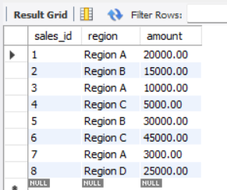
------Aggregation: First, find the total sales per region using GROUP BY and SUM(). ----
6.select region,sum(amount) as total_amount from sales group by region;

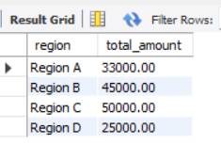

--Window Function: Now, wrap the first query as a subquery (or CTE) and apply a window function to rank the regions by their total sales ---
7. select *, rank()over (order by total_amount desc) as sales_rank from(select region,sum(amount) as total_amount from sales group by region) as region_sales;
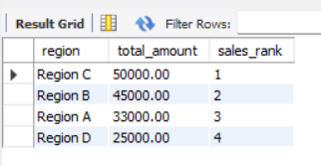

Project 2: Customer Purchase History Analysis

Objective: For each customer, find their last order date and the difference in days between their first two orders
1. create database mini42_db;
2.use mini42_db;
3. create table customer(order_id int primary key,customer_name varchar(50),order_date date,price decimal(10,2));
4. insert into customer values(101,'customer A','2025-01-05',500),(102,'customer B','2025-01-05',200),(103,'customer C','2025-01-05',100),(104,'customer A','2025-01-06',150),
(105,'customer B','2025-01-07',300),(106,'customer B','2025-01-08',250),(107,'customer C','2025-01-06',200);
5.select * from customer;
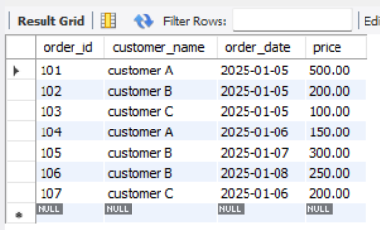
------Window Function (LAG): To find the difference between the first two orders-----
6. select customer_name,order_id,order_date,row_number()over(partition by customer_name order by order_date)as row_num,
lag(order_date)over(partition by customer_name order by order_date)as previous_order_date from customer;
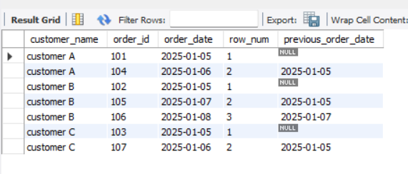
-----Window Function (MAX): To find the last order date for each customer –

7. select customer_name,order_date,max(order_date)over (partition by customer_name)as last_order_date from customer;
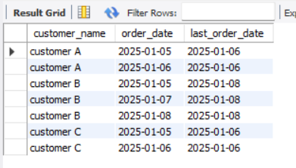

Project 4: Employee Ranking Dashboard

Objective: Create a dashboard of employee rankings by performance score, ranked within their respective departments
1. create database mini43_db;
2.use mini43_db;
3. create table employee(emp_id int primary key,emp_name varchar(50),department_name varchar(50),performance_score decimal(10,2));
4.insert into employee values(101,'priya','HR',3.5),(102,'Ram','HR',4),(103,'Ashok','IT',3),(104,'vino','finance',4),(105,'Uma','IT',4.5),(106,'krish','Finance',5);
5. insert into employee values(107,'siva','finance',5),(108,'karthick','HR',3.5),(109,'arul','HR',3),(110,'Madhu','IT',4.5);
6. select * from employee;
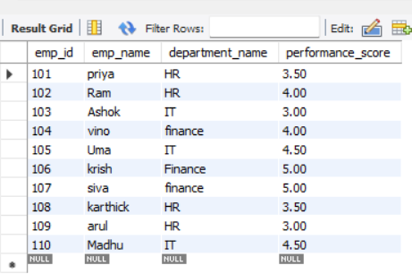

------Use DENSE_RANK() OVER (PARTITION BY department ORDER BY performance_score DESC) and then display the results----
7. select * ,dense_rank()over(partition by department_name order by performance_score desc) as Den_rank from employee;
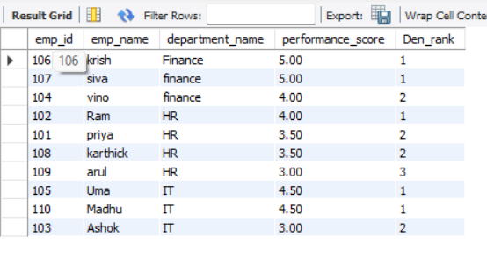

Project 4: Customer Churn Analysis

Objective: Identify customers with long gaps between orders
1. create database mini44_db;
2.use mini44_db;
3. create table customer(order_id int primary key,customer_name varchar(50),order_date date,price decimal(10,2));
4.insert into customer values(101,'customer A','2025-01-05',500),(102,'customer B','2025-01-05',200),(103,'customer C','2025-01-05',100),(104,'customer A','2025-01-06',150),
(105,'customer B','2025-01-07',300),(106,'customer B','2025-01-08',250),(107,'customer C','2025-01-06',200);
5. insert into customer values(108,'customer A','2025-01-15',300),(109,'customer B','2025-02-01',150),(110,'customer C','2025-02-10',100);
6. select * from customer;
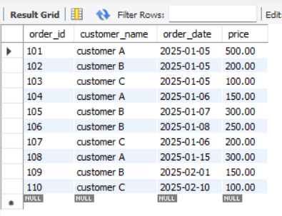
------Use LAG() on order_date to calculate the difference between the current order and the previous one for each customer, and then filter for large gaps. ----
7.select customer_name,order_id,order_date,
lag(order_date)over(partition by customer_name order by order_date)as previous_order_date,DATEDIFF(order_date, LAG(order_date) OVER (
PARTITION BY customer_name ORDER BY order_date)) AS days_between from customer;
